Data Center Remote Monitoring and Control System

Veri Merkezi Uzaktan İzleme ve Kontrol Sistemi

Sinan Can Keskin, Ali Kemal Cem Özdemir Doç. Ali Gökhan Yavuz

Computer Engineering Department

Yıldız Technical University

İstanbul, Turkey

{l1111055,10011057}@std.yildiz.edu.tr

gokhan@ce.yildiz.edu.tr

*Abstract*—**The main purpose of developing a Data Center Automation System is increasing the security and operating capability of the data centers. With today’s technology, its becoming more and more important to save out data and with this, automation projects are also becoming more important for every field that would be necessary.**

**Shortly, the system is going to have a hierarchical structure among a master device RPi and multiple slave (Arduino) devices that connected to the racks, which are responsible for reading and transferring data over a wireless communication protocol. We want to read temperature, humidity, and air flow information from the racks, which are very important for us. The data will be read trough sensors and transmitted to the master device. What RPi is going to do is collecting and storing the data in a local database (SQL), processing the data and sending to the cloud database which will be connected with a web interface to monitor the events and changes that are happening in the racks and inside of the data center.**

Besides, we want to measure the temperature of the room and trying to implement an alarm system for fire and flooding inside of the data center with using smoke and water level sensors.

Keywords — Raspberry Pi; Automation; Data Center

***Özetçe*—Veri Otomasyon Sistemi Projesi’nde amaçlanan, günümüzde çok önemli hale gelen veri merkezlerinin güvenliğini arttırmak ve çalışabilirliğini üst seviyeye çıkarmaktır. Günümüz teknolojisinde otomasyon sistemleri giderek önemlerini arttırmaktadırlar. Gerek elektrik kontrolünde gerek akıllı sistemler geliştirmelerinde bize büyük faydalar ve kolaylıklar sağlamaktadırlar. Buradan yola çıkarak veri merkezlerine de otomasyon sistemleri entegre edilerek her türlü sorunun önüne geçilmeye, oluşan sorunlara en hızlı şekilde müdahale imkanı sağlanmaya çalışılmıştır.**

**Sistemin genel çalışmasını tarif etmek gerekirse, veri merkezindeki her türlü çevresel faktörlere duyarlı bir sistem olması düşünülmektedir. Kabinetlerden sensorler ile alınacak sıcaklık, nem, hava akımı bilgileri, Arduino modüllerine, oradan da kablosuz haberleşme ile master device olarak düşünülen RPi’a aktarılacaktır. RPi’a alınan veriler yerel veri tabanında depolanacak, buradan işlenerek bulut veri tabanına aktarılacaktır. Bulut veri tabanı aynı zamanda bir web ara yüzü ile bağlantılı olup, bu web arayüzünde belirli aralıklarla yenilenen veriler görüntülenebilecek, oluşan olaylar bu web ara yüzünden gözlenebilecektir.**

Aynı zamanda kabinetler haricinde odanın içerisindeki sıcaklık bilgisi alınacaktır. Duman ve su seviyesi sensorleri ile oda içerisindeki yangın ve su baskınları durumlarına karşı uyarı sistemleri geliştirilmesi amaçlanmıştır.

Keywords — Raspberry Pi; Otomasyon; Veri Merkezi

# INTRODUCTION

.

* ***Introduction:*** In today’s technology, storing and protection of the data is getting more important every day. Yes, we must protect our data aganist hackers and also we must save our data from external disasters, such as fire, water floats.

To achive this purpose, we decided to improve a system thats so simple and useful by using Raspberry Pi and Arduino.

Data center dependence has evolved into a complicated environment with a mixture of new and legacy equipment and a myriad of devices and strategies. It is not uncommon for modern data centers to have a varied mix of entry-level to enterprise-class servers running various operating systems, firewalls, gateways, switches, routers, environmental monitoring solutions, building automation systems, and uninterruptible power supplies (UPS) to name just a few. This list continues to grow in today‟s managed-systems environment. But, all the efforts to deliver faster and constant access to corporate information assets, improve uptime, and shorten windows of recovery for disasters have driven complexities up and utilization rates down[1].

* ***System Design:*** Remote Data Center Monitoring System, offers you multiple slave Arduino devices, sensor and modules to communicate with the Raspberry Pi as a master device, that will be placed onto the rack computers. So, we will be able to measure temperature, air flow, fire situations from the computers. With the help of the RF communication mudeles, we will be transmitting the data over Raspberry Pi. After transmission, Raspberry Pi will be storing the important data, such as events that ocur unsually in the system. At the same time, the system will allow you to monitor the data center over the internet via it’s web interface as real time. Users that were authorizated by the administration of the system will be able to monitor the system and event files over the web interface.

**Figure 1.** System Design 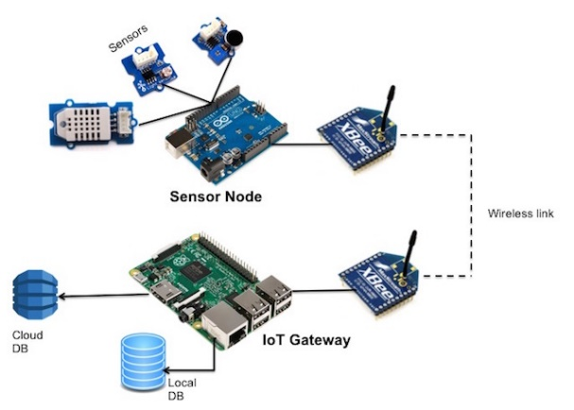

**Figure 1.** System Design

**Table 1.** Comparsion of the existing systems

|  |  |  |  |
| --- | --- | --- | --- |
| Sensors \ Devices | WebCTRL | Schneider Electrik | DCMS |
| Light | √ | √ | X |
| CO2 | √ | √ | √ |
| Temperature | √ | √ | √ |
| Air Flow | X | √ | √ |
| Humidity | √ | √ | √ |
| Self-Optimizing | X | √ | X |
| Wi-Fi | X | X | √ |

In the table above, there is a comparsion of the existing two systems and our system.

* ***Experimetal Study:*** Sensors were directly connected to the arduino modules to read the data. Each module was built seperatly. After building modules and tests, all modules are summerized in one board.

Acquistited data are transmitted to the Raspberry Pi, whic is designed to be the master device in the system. The data will be collected in the SQLite data base. In the SQLite, we will create special table for event logs. Thus, we will be able to get our event logs via our web interface.

We tested our modules, and saw that system is working quite well.

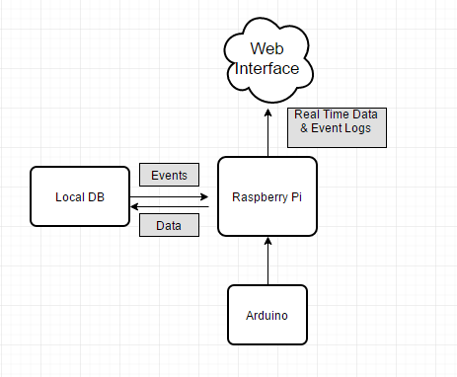

**Figure 2.** E-R diagram of the System

Arduinos will be atached to the rack computers wirelessly. 9V batteries will be feeding Arduinos. Arduinos are not consuming so much power because of the sensors that are used are scaled to not comsume power. We lowered the acquisition rate, thus lower the power consumption.

* ***Results and Discussion:*** Once we completed the system, we experienced how to design a system that includes communication between different platforms, collecting, storing and processing the data as well as the getting important results from the data.

That has been an outstanding experience for us to learn how to work with real time systems, internet of things and cloud data processing.

* ***Conclusion:*** The system that we improved, is implemented in to our Computer Engineering Departmanet’s data center. We measured every parameter that we want from the system. We uploaded the data into our database and cloud system. We managed to monitor our system over the internet from different platforms by the help of our responsive desing of web interface.

##### REFERENCES

1. Lantronix, "A GLOBAL LEADER IN ENTERPRISE IoT," 2016. [Online].Available: <http://www.lantronix.com//DataCenterMngmnt> May 28, 2016.

[2] "Data center," in Wikipedia, Wikimedia Foundation, 2016. [Online]. Available: [https://en.wikipedia.org/wiki/Data_center](https://l.facebook.com/l.php?u=https%3A%2F%2Fen.wikipedia.org%2Fwiki%2FData_center&h=yAQGKcY-B). Accessed: May 28, 2016.